**PROJECT 02: INSTAGRAM USER ANALYTICS**

1. **Marketing Analysis:**
2. **Loyal User Reward :** Identify the five oldest users on Instagram from the provided database.

**Code:** select id, username, created_at

from users

order by created_at

limit 5;

**Result:** Here areFive oldest users on Instagram which are selected for Loyal user Rewards.

|  |  |  |
| --- | --- | --- |
| **id** | **username** | **created_at** |
| 80 | Darby_Herzog | 2016-05-06 00:14:21 |
| 67 | Emilo_Bernier52 | 2016-05-06 13:04:30 |
| 63 | Elenor88 | 2016-05-08 01:30:41 |
| 95 | Nicole71 | 2016-05-09 17:30:22 |
| 38 | Jordyn.jacobson2 | 2016-05-14 07:56:26 |

**Output:**

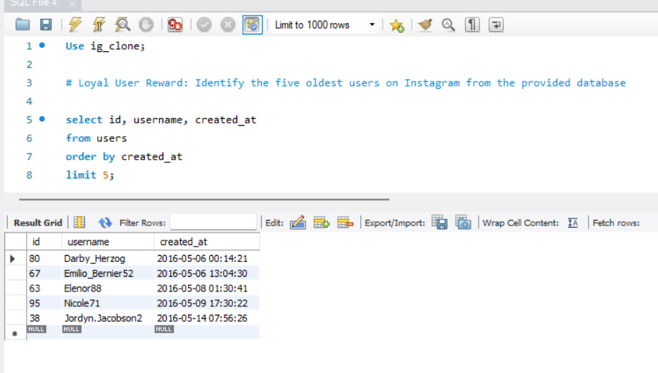

1. **Inactive User Engagement:** Identify users who have never posted a single photo on Instagram.

**Code:** select u.id, u.username, u.created_at

from users as u

left join photos as p on u.id = p.user_id

where p.id is NULL

limit 50;

**Result:** Here is the users who have never posted a single photo on Instagram.

|  |  |  |  |
| --- | --- | --- | --- |
| **Sr.No** | **id** | **username** | **created_at** |
| 1 | 5 | Aniya_Hackett | 07-12-2016 01:04 |
| 2 | 7 | Kasandra_Homenick | 12-12-2016 06:50 |
| 3 | 14 | Jaclyn81 | 06-02-2017 23:29 |
| 4 | 21 | Rocio33 | 23-01-2017 11:51 |
| 5 | 24 | Maxwell.Halvorson | 18-04-2017 02:32 |
| 6 | 25 | Tierra.Trantow | 03-10-2016 12:49 |
| 7 | 34 | Pearl7 | 08-07-2016 21:42 |
| 8 | 36 | Ollie_Ledner37 | 04-08-2016 15:42 |
| 9 | 41 | Mckenna17 | 17-07-2016 17:25 |
| 10 | 45 | David.Osinski47 | 05-02-2017 21:23 |
| 11 | 49 | Morgan.Kassulke | 30-10-2016 12:42 |
| 12 | 53 | Linnea59 | 07-02-2017 07:49 |
| 13 | 54 | Duane60 | 21-12-2016 04:43 |
| 14 | 57 | Julien_Schmidt | 02-02-2017 23:12 |
| 15 | 66 | Mike.Auer39 | 01-07-2016 17:36 |
| 16 | 68 | Franco_Keebler64 | 13-11-2016 20:09 |
| 17 | 71 | Nia_Haag | 14-05-2016 15:38 |
| 18 | 74 | Hulda.Macejkovic | 25-01-2017 17:17 |
| 19 | 75 | Leslie67 | 21-09-2016 05:14 |
| 20 | 76 | Janelle.Nikolaus81 | 21-07-2016 09:26 |
| 21 | 80 | Darby_Herzog | 06-05-2016 00:14 |
| 22 | 81 | Esther.Zulauf61 | 14-01-2017 17:02 |
| 23 | 83 | Bartholome.Bernhard | 06-11-2016 02:31 |
| 24 | 89 | Jessyca_West | 14-09-2016 23:47 |
| 25 | 90 | Esmeralda.Mraz57 | 03-03-2017 11:52 |
| 26 | 91 | Bethany20 | 03-06-2016 23:31 |

**Output:**

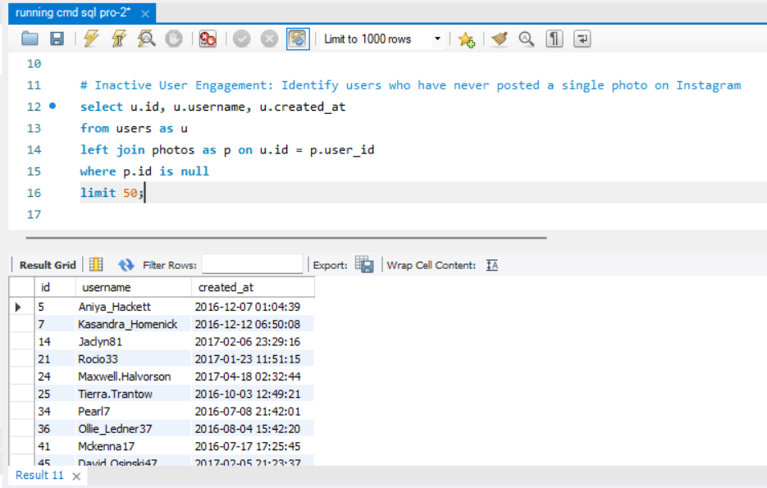



1. **Content Winner Declaration:** Determine the winner of the contest and provide their details the team.

**Code:** Select p.id as photo_id, p.user_id, u.username, count(l.photo_id) as like_count

from photos as p

join likes l on p.id = l.photo_id

join users u on p.user_id = u.id

group by p.id, p.user_id, u.username

order by like_count desc

limit 1;

**Result:** Here are the winner of the contest and provide their details the team.

|  |  |  |  |
| --- | --- | --- | --- |
| **photo_id** | **user_id** | **username** | **like_count** |
| 145 | 52 | Zack_Kemmer93 | 48 |

**Output:**

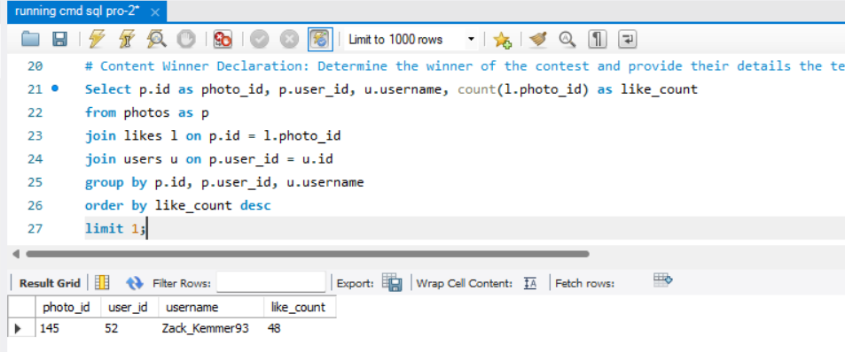

1. **Hashtag Research :** Identify and suggest the top five most commonly used hashtag on the platform.

**Code:** select t.tag_name, count(pt.photo_id) as tag_count

from tags as t

join photo_tags as pt on t.id = pt.tag_id

group by t.tag_name

order by tag_count desc

limit 5;

**Result:** Here is top five most commonly used hashtag.

|  |  |
| --- | --- |
| **tag_name** | **tag_count** |
| Smile | 59 |
| Beach | 42 |
| Party | 39 |
| Fun | 38 |
| concert | 24 |

**Output:**

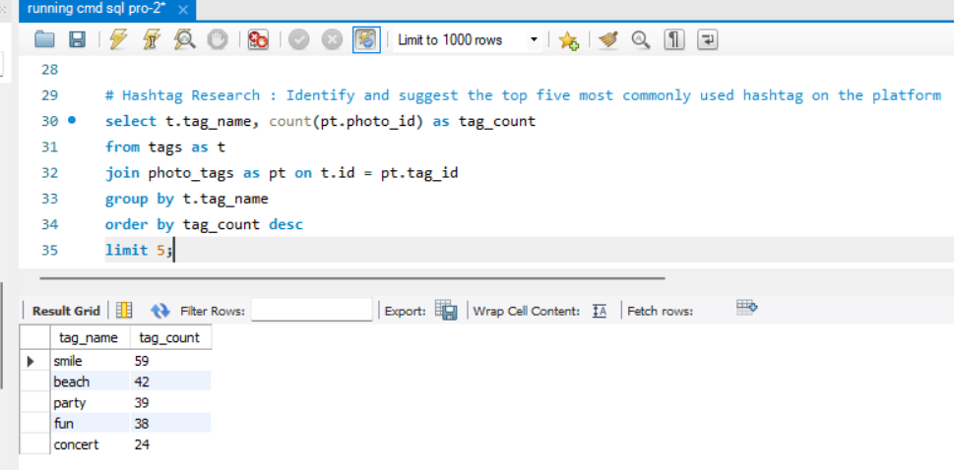

1. **Ad Campaign Launch:** Determine the day of the week when most users register on Instagram. Provide insights on when to schedule an ad campaign.

**Code:** select dayname(created_at), count( * )

from users

group by dayname(created_at)

order by count( * ) desc

limit 1;

**Results:** Here is the day of week when most user register on Instagram.

|  |  |
| --- | --- |
| **Dayname(created_at)** | **Count( * )** |
| Thursday | 16 |

**Output:**

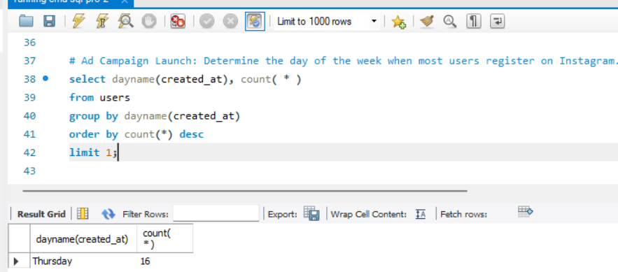

1. **Investor Metrics:**
2. **User Engaement:** Calculate the average number of osts per use on Instagram. Also, provide the total number of photos on Instagram divided the total number of users.

**Code:** select count( * ) / count(distinct user_id) as avg_posts_per_user,

(count( * ) / (select count( * ) from users)) as photos_per_user

from photos;

**Result:**

|  |  |
| --- | --- |
| **avg_posts_per_user** | **photos_per_user** |
| **3,4730** | **2,5700** |

**Output:**

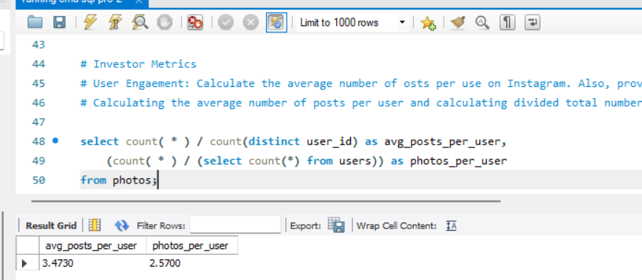

1. **Bots & Fake Accounts:** Identify users who have liked every single photos on the site, as this is not typially possible for a normal user.

**Code:** Select l.user_id, u.username, COUNT(l.photo_id) AS total_likes

from likes l

join users u on l.user_id = u.id

group by l.user_id

having total_likes = (select COUNT(*) from photos);

**Result:**

|  |  |  |
| --- | --- | --- |
| **user_id** | **username** | **total_likes** |
| 5 | Aniya_Hackett | 257 |
| 14 | Jaclyn81 | 257 |
| 21 | Rocio33 | 257 |
| 24 | Maxwell.Halvorson | 257 |
| 36 | Ollie_Ledner37 | 257 |
| 41 | Mckenna17 | 257 |
| 54 | Duane60 | 257 |
| 57 | Julien_Schmidt | 257 |
| 66 | Mike.Auer39 | 257 |
| 71 | Nia_Haag | 257 |
| 75 | Leslie67 | 257 |
| 76 | Janelle.Nikolaus81 | 257 |
| 91 | Bethany20 | 257 |

**Output:**

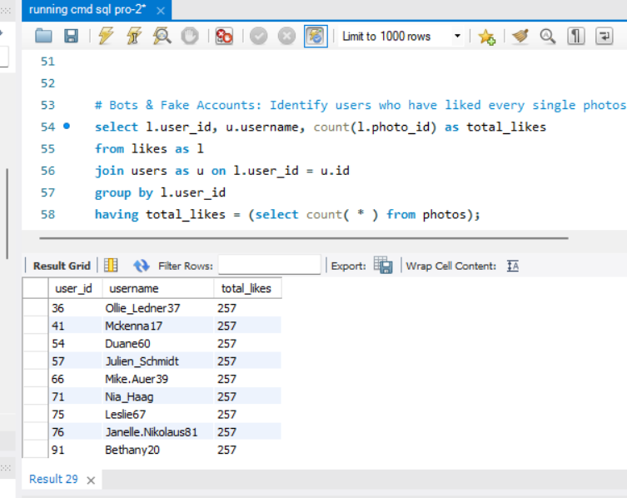



**Project Description:**

The analyzes described in this project on user interaction and engagement data from a simulated Instagram database (ig_clone) are meant to provide actionable insights for Instagram's product team and management.

The analyses sought to find answers to key business questions that concern user loyalty, activity, content popularity, and possible bot accounts. These very insights help taken by Instagram into data-driven decisions related to its marketing strategies, product development, and investor relations.

**Approach:**

The project was done in a structured way: First, the ig_clone database was set up using the provided SQL script in MySQL Workbench. Then, each question from the marketing and investor's list was analyzed as to what data points would be needed and what SQL queries to run. The necessary queries were developed and run in MySQL Workbench, with captured results sent for analysis.

Finally, the query results were interpreted to give insightful conclusions about user behavior, platform trends, and potential bot activity.

**Tech Stack Used:**

MySQL Workbench (version 8.0) was provided for this project because of its straightforward user interface and all-encompassing features to control database management, SQL development, and query execution.

**Insights:**

In the analysis, these several tasks were reported: 1) Loyal User Reward, 2) Inactive User Engagement, 3) Contest Winner Declarartion, 4) Hashtag Research, 5) Ad Compaign Research, 6) User Engagement and 7)Bots & Fake Accounts.

**Result:**

We learned a lot through the project about Instagram users-their most loyal users, those who aren't very active as posters, the contest winners, hashtags that ranked highest, the best times to run ads, figure out just how active the users are, and who could have created a fake account. This information will help Instagram's teams make better decisions about marketing, new features, and what to tell investors.